PocketSmart AI
Smart Budget & Recommendation Assistant
Project Documentation
Based on the supplied project demonstration video and demo-document format
Project Type | AI-powered web application
Backend | Python + FastAPI
AI Engine | Google Gemini (gemini-1.5-flash shown in demo)
Frontend | HTML, CSS, JavaScript + Jinja2

1. Project Overview
PocketSmart AI is a budget-planning and recommendation web application demonstrated in the supplied video. It accepts a user's budget and category-specific requirements, processes them through an AI recommendation layer, and presents a structured allocation or recommendation result. The demonstrated planning areas include Home Interior, Party Planning, and Jewelry.

1.1 Objectives
- Provide a simple interface for entering a spending budget and category-specific requirements.
- Use generative AI to interpret planning requirements and produce recommendations.
- Break a total budget into meaningful categories and show estimated prices and quantities.
- Support multiple planning scenarios through a common web application.
- Maintain a modular backend with routes, templates, recommendation logic and AI integration.

1.2 Key Features Demonstrated
- Home Interior Budget Planner with budget and fixture/furniture quantity inputs.
- Personalized Home Budget Plan with category allocations, item descriptions, estimated prices and quantities.
- Jewelry Budget Planner and generated Jewelry Budget Plan.
- Party-planning pages/routes represented in the project structure.
- Authentication/session-related routes and recommendation/history-oriented pages.
- Dedicated Gemini utility module for AI response generation.

2. Technology Stack
Layer | Technology | Purpose
Frontend | HTML / CSS / JavaScript | Forms, navigation and result presentation.
Templates | Jinja2 | Server-rendered planner and result pages.
Backend | Python + FastAPI | Routing, request handling and application services.
AI | Google Gemini | Budget interpretation and recommendation generation.
Configuration | python-dotenv / .env | Loads configuration such as the Gemini API key.
Development | VS Code + local server | Implementation, debugging and demonstration.

2.1 AI Integration
The video shows a gemini_utils.py module that imports Google's generative-AI library, loads environment variables, reads the GEMINI_API_KEY, configures the client, initializes a Gemini model, and exposes a helper function for generating content from prompts.
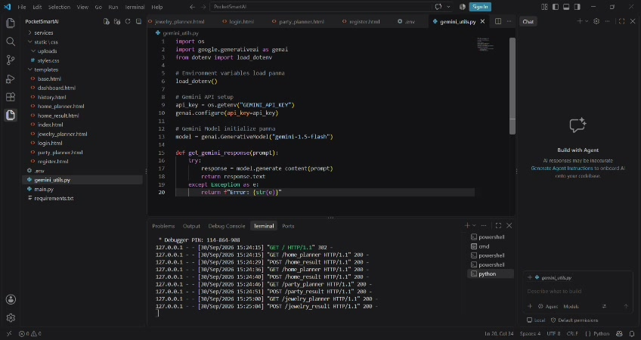
Figure 1. Gemini utility module shown in the project video.

3. System Architecture
The demonstrated application follows a layered web architecture: browser UI → FastAPI backend → recommendation logic → Gemini utility → structured Jinja2 result page.
1. User Interface | Browser pages for Home, Party and Jewelry planning.
2. FastAPI Layer | Routes requests, authentication/session operations and result pages.
3. Recommendation Layer | Prepares category-specific inputs and recommendation prompts.
4. Gemini Utility | Sends prompts to the configured Gemini model and returns generated content.
5. Result Templates | Displays allocations, item details, prices and quantities.

3.1 Project Structure Observed
- services/ for reusable logic.
- static/ and static/css/ for frontend assets.
- uploads/ for uploaded files.
- templates/ for planner, result, dashboard and history pages.
- gemini_utils.py for Gemini setup and response generation.
- main.py for the FastAPI application.
- .env for configuration.
- requirements.txt for Python dependencies.
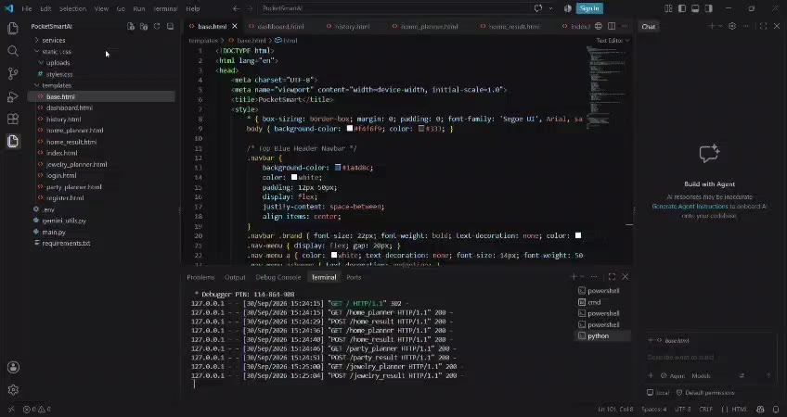
Figure 2. Project structure and running FastAPI application visible in the development environment.

4. Functional Modules

4.1 Home Interior Budget Planner
The Home Interior Planner collects a total budget and fixture/furniture quantities. The demonstrated screen includes fields for light sockets, ceiling fans, furniture items and dining tables, followed by a Generate Budget Plan button.
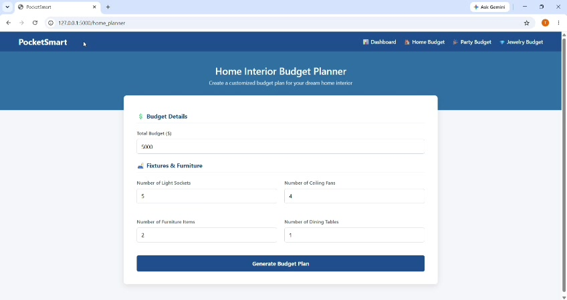
Figure 3. Home Interior Budget Planner input screen.
The generated page presents a personalized allocation. The visible result contains sections such as Home Lighting & Electricals, Home Cooling & Fans and Living Room Furniture, with allocated amounts and item-level descriptions, prices and quantities.
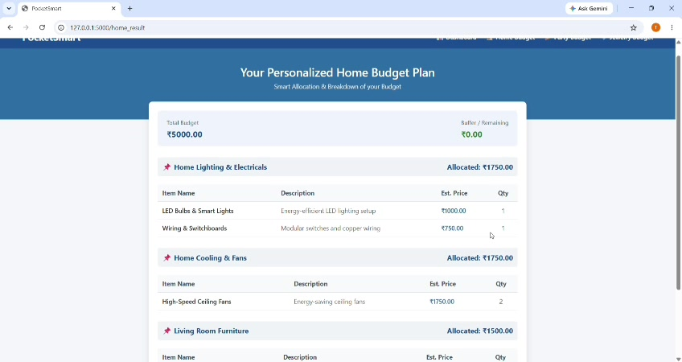
Figure 4. Personalized Home Budget Plan generated by the application.

4.2 Jewelry Budget Planner
The video also demonstrates the Jewelry planning flow. The generated Jewelry Budget Plan organizes recommendations into jewelry-related categories and shows allocated amounts, item details and quantities.
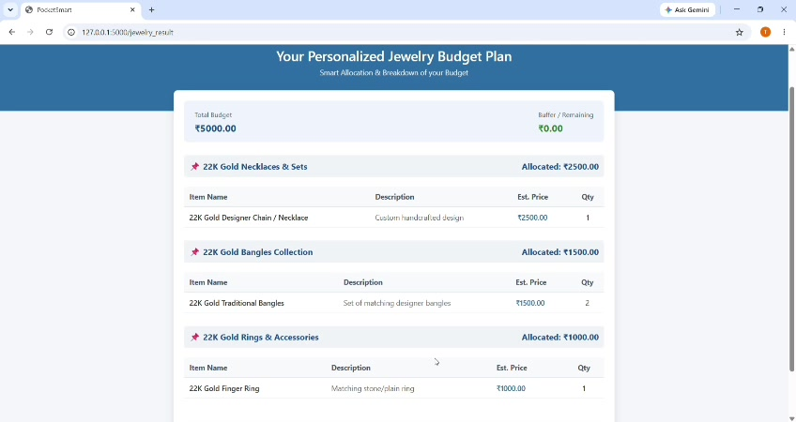
Figure 5. Personalized Jewelry Budget Plan shown in the demonstration.

4.3 Party Budget Planner
The project structure includes party_planner.html and party_result.html along with backend request activity. The module is designed to accept event-related inputs and return a budget-aware party plan.

5. Backend Implementation
The project video shows FastAPI as the backend framework. The backend contains planner routes, generated-result routes, authentication/session operations and supporting recommendation logic. The development console shows successful GET and POST requests while the application is running locally.

5.1 Main Route Responsibilities
Route | Responsibility
/generate-home | Processes home-planning inputs and generates home recommendations.
/generate-party | Processes party-planning information and generates event recommendations.
/generate-jewelry | Supports the jewelry-planning workflow and result generation.
/login | Authenticates an existing user.
/register | Registers a new user.
/logout | Ends the current user session.
/token | Provides authentication token functionality.
/session-info | Returns current session information.
/session-data | Provides session-specific data.
/history | Supports previous recommendation activity.
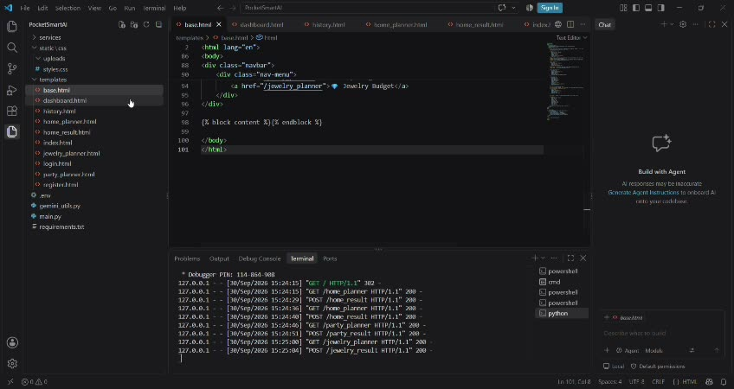
Figure 6. Backend/template implementation and server request logs visible in the video.
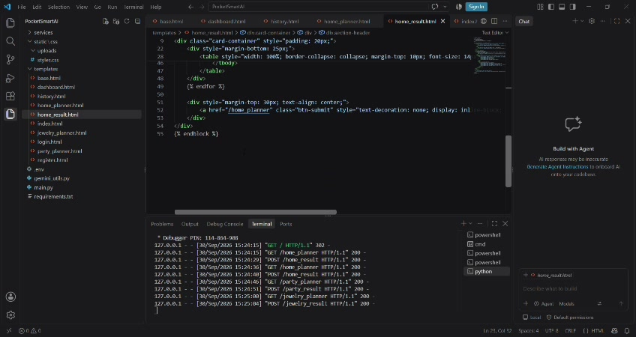
Figure 7. Backend route/template logic shown during the demonstration.

6. Recommendation Workflow
Step 1 – Input Collection: The user selects a planner and enters a budget plus category-specific requirements.
Step 2 – Request Handling: FastAPI receives and processes the submitted data.
Step 3 – Recommendation Preparation: The backend maps the input to the selected category and prepares recommendation content.
Step 4 – AI Generation: The Gemini utility sends the prompt to the configured Gemini model and obtains generated content.
Step 5 – Budget Allocation: The application organizes the result into categories with allocations, estimated prices and quantities.
Step 6 – Result Rendering: A Jinja2 result template presents the personalized plan in a structured layout.

7. User Interface and Output Design
The browser UI uses a consistent blue navigation/header theme and card-based content areas. Planner pages use grouped input sections, while result pages use summary panels followed by category tables.
- Top navigation provides Dashboard, Home Budget, Party Budget and Jewelry Budget.
- Planner forms group related inputs under clear headings.
- Result pages show total budget and remaining/buffer amount.
- Each recommendation category has an allocated amount.
- Item rows show name, description, estimated price and quantity.
- Additional suggestions can be displayed below the main recommendations.
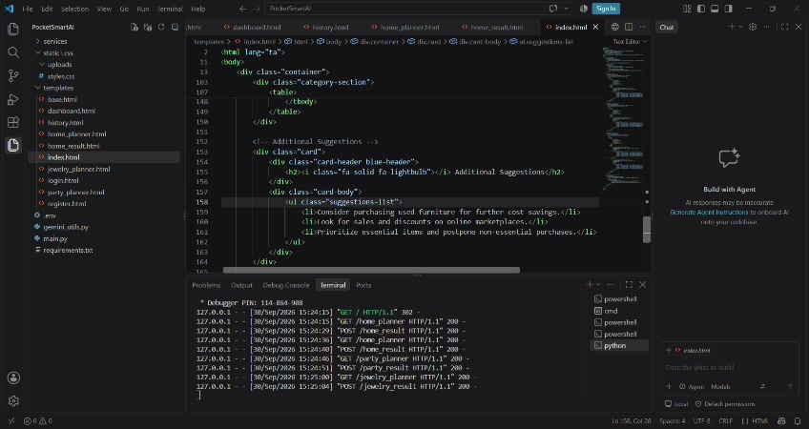
Figure 8. Result-template code showing category recommendations and additional suggestions.

8. Testing and Demonstration Evidence
The video contains successful local HTTP request logs while the application is running. The browser demonstration shows planner forms loading and generated budget plans being displayed.
Test Area | Observed Evidence | Expected Outcome
Home planner input | Budget and quantity fields accept user input. | Planning request is submitted.
Home result | Personalized Home Budget Plan is displayed. | Budget is allocated across categories and items.
Jewelry result | Personalized Jewelry Budget Plan is displayed. | Jewelry categories and estimated items are shown.
Backend routing | GET/POST requests appear in the server console. | Frontend and backend communicate successfully.
Gemini integration | gemini_utils.py configures the model and response helper. | AI-generated content can be requested.

9. Advantages of the Proposed System
- Combines budget planning with AI-generated recommendations in one interface.
- Supports multiple planning categories using reusable backend patterns.
- Presents AI output as structured budget allocations rather than raw text.
- Uses a modular FastAPI project structure that can be extended.
- Provides a foundation for live product/service integrations and richer personalization.

10. Future Enhancements
- Connect recommendation results to live product/service APIs with current prices and availability.
- Add stronger validation and budget-consistency checks.
- Expand image-aware recommendations for the Jewelry planner.
- Add persistent user profiles, saved plans and richer recommendation history.
- Introduce comparison, filtering and sorting of recommended products.
- Add production deployment configuration and secure secret management.
- Create automated tests for routes, budget calculations and AI response handling.

11. Conclusion
PocketSmart AI demonstrates a practical integration of generative AI with a FastAPI web application for budget-aware planning. The project video shows the application running locally, the project structure, Gemini integration code, planner templates, backend request handling, and generated Home and Jewelry budget results. The architecture provides a clear base for extending the system to additional planning scenarios, richer personalization and live recommendation sources.

Appendix – Additional Video Evidence
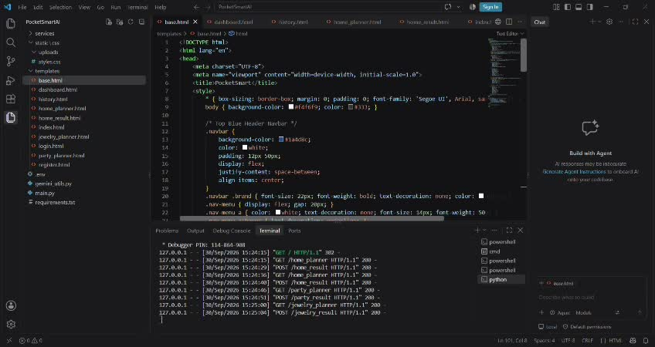
Backend/template implementation evidence.
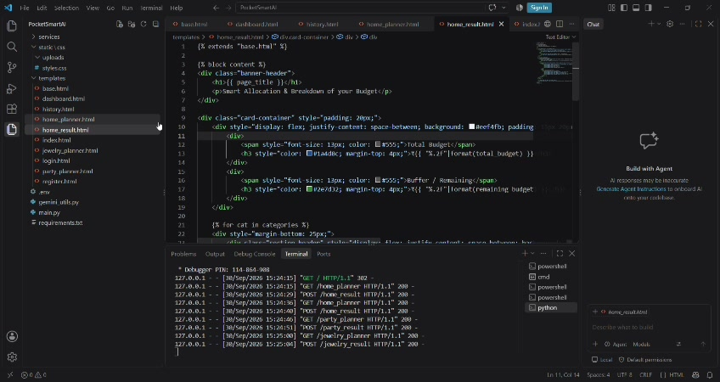
Budget result template logic.
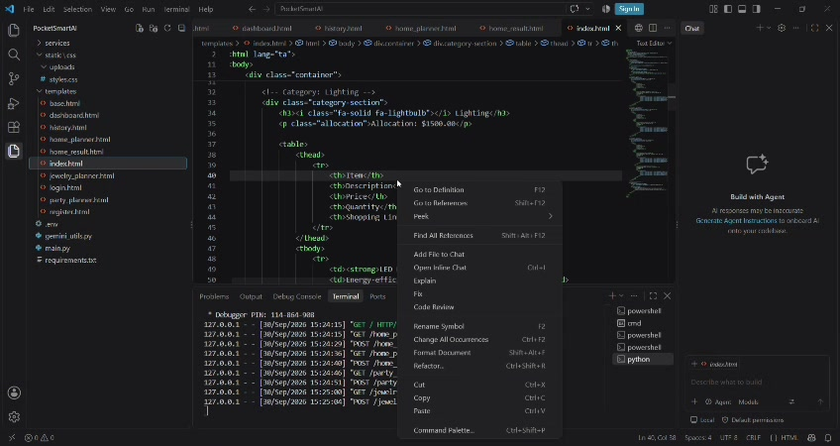
Category table implementation.
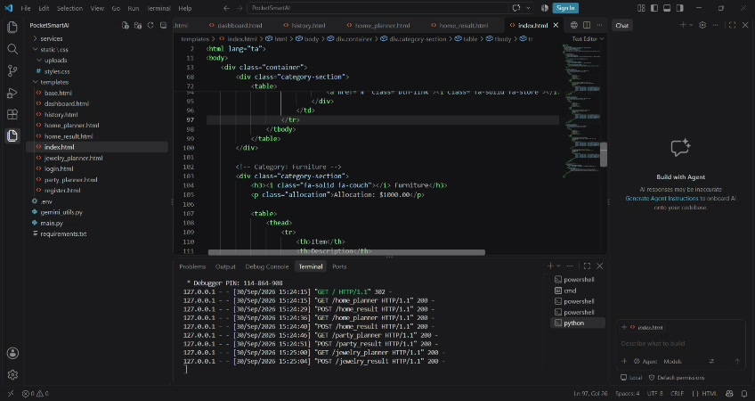
Recommendation/result template logic.
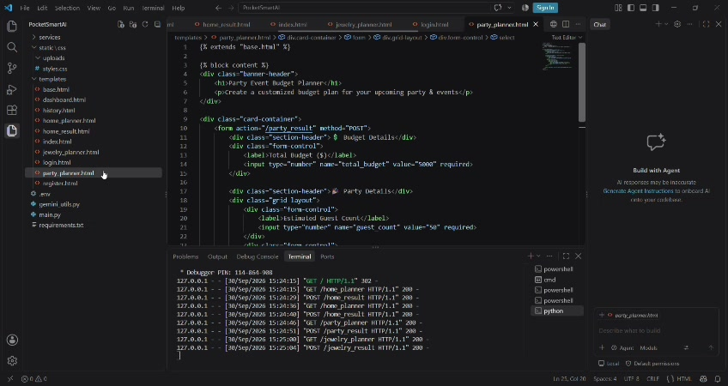
Planner/result template implementation.
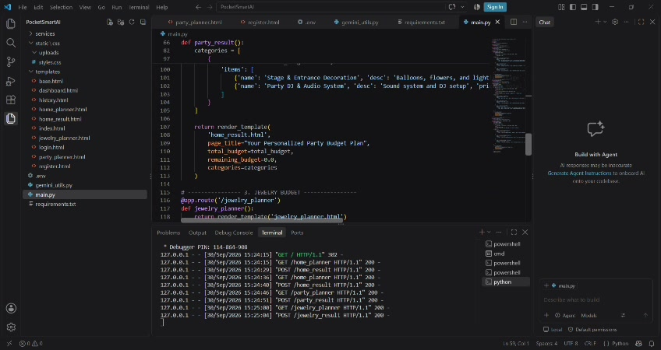
FastAPI backend logic visible in the demonstration.

